**EXPERIMENT No.: 8**

**NAME OF EXPERIMENT:** Various graphs in Tableau, Integration of Map and geo-locations, Creating Interactive Dashboard and Publishing your Dashboard to Tableau Public Site.

**Name –Swayam Terode**  **Roll No.: C70 Division : C**

**Date of Performance:** ______________ **Sign of Teacher:**

# Build a Simple Map

You can build several different types of maps for your geographic analysis in Tableau. If you're new to maps, or simply want to take advantage of the built in mapping capabilities that Tableau provides, you can create a simple point or filled (polygon) map similar to the examples below.

**Prerequisites**: To build a simple map, your data source must contain location data (location names, or latitude and longitude coordinates).

**INPUT:** sample axles file which has country name and latitude and longitude coordinates

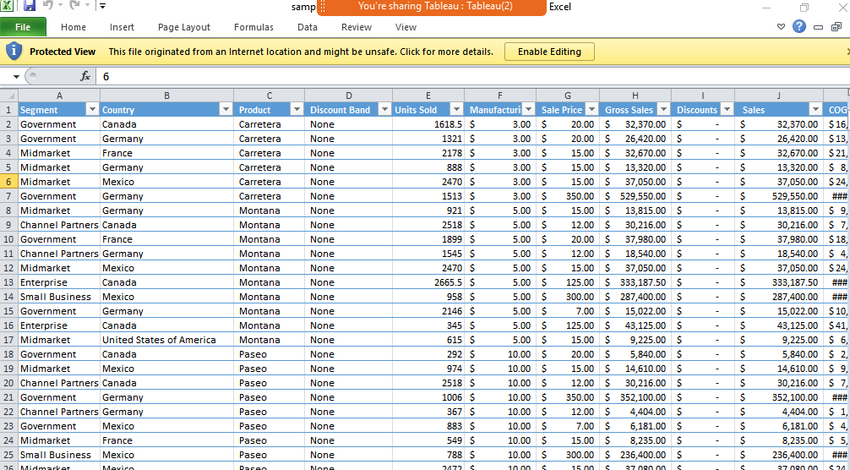

**OUTPUT:**

